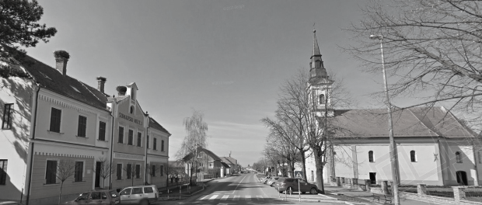
24 ^{th} OPEN CHESS TOURNAMENT ”BOŠNJACI 2019”
24. OPEN BOŠNJACI

Bošnjaci, JAN 3rd – JAN 9th 2019.

Organizer: Chess Club “BOŠNJACI“
Date and Locaton: 3rd - 9th of January, 2019. Bošnjaci, elementary school's gymnasium
Participation right: All players from Croatia and foreign countries.
Competition system: Swiss, FIDE version, 9 rounds (joint tournament for male and female chess-players)
Game rate: 90 minutes + 30 seconds bonification by every move (from the beginning of the game). Tournament will be rated by FIDE.
Prize fund: cca 4800. € net (in Croatian kuna)

1. place 6500 kn | 6. place 1600 kn
2. place 4500 kn | 7. place 1100 kn
3. place 3500 kn | 8. place 1000 kn
4. place 2500 kn | 9. place 900 kn
5. place 2000 kn | 10. place 800 kn

Particular prizes in kuna:
For female chess players 1600,00 1200,00 800,00
in the end of the Tournament, placing of female chess-players will be made)
Best players according to rating
ELO 1000-1800 500,00 400,00 300,00
ELO 1801-2000 500,00 400,00 300,00
ELO 2001 – 2200 600,00 500,00 400,00
ELO 2201 – 2400 700,00 600,00 500,00

Best male and female 3 kadets: medals
Special prizes:
Best positioned player from VS county 500,00
Best female from VS county 400,00
Best junior from VS county 300,00
Best cadet from VS county 300,00
Best positioned player from CK“Bosnjaci“ 300,00
Prizes are not cumulative. No one can win more than 1 Money Prize.
Entry fee: upfront 200 kn (untill 25th December 2018) or on the opening day 250 kn.
(Organiser can allow participants don´t pay fees if that is in best tournament interest.)
Tournament schedule: Registrations until 5.00 PM January ,3rd 2019.
Opening ceremony at 5.30 PM
I. round Wednesday 03.01. 6.00 pm
II. round Thursday 04.01. 10.00 am
III. round Thursday 04.01. 5:00 pm
IV. round Friday 05.01. 5:00 pm
V. round Saturday 06.01. 10.00 am
VI. round Saturday 06.01. 5:00 pm
VII. round Sunday 07.01. 5:00 pm
VIII. round Monday 08.01. 5:00 pm
IX. round Tuesday 09.01. 9.30 am
Closing ceremony, awardings and banquet after 9. round
Obligations: Each participiant has to bring there own digital chess clock

Private accomodation: Bošnjaci, a night's accomodation cca 150,00 kn, (cca 20 € single room,
14€ double room)
reservations phone number: +385 98 9 616 620. or +385 95 517 1719

Registration and information:
Ivan Jelić +385 91 64 47 218 ivan_jel@net.hr
Branko Vidačković +385 95 517 1719 or e-mail: bvidacko@gmail.com

Main sponsor: municipality Bošnjaci,

Bošnjaci 10th October 2018.

Chess Club “BOŠNJACI“

